UNOFFICIAL TRANSLATION

Republic of Serbia
AGENCY FOR THE PREVENTION OF CORRUPTION

STATISTICAL ANALYSIS OF THE CATALOG OF GIFTS RECEIVED IN 2022

May 2023

CONTENTS
- INTRODUCTION 3
- STATISTICAL OVERVIEW OF GIFTS RECEIVED BY YEAR AND MONTH 4
- STATISTICAL OVERVIEW OF GIFTS RECEIVED ACCORDING TO TYPE OF GIFTS AND PROPERTY REGIME 6
- RELATION OF PUBLIC AUTHORITIES AND THE PROPERTY REGIME OF THE GIFTS 7
- THE RELATION OF THE LEVEL OF PUBLIC AUTHORITY AND THE TYPE OF GIFT, NAMELY THE PROPERTY REGIME OF THE GIFT 10
- THE RELATION OF PUBLIC OFFICES AND PROPERTY REGIME OF THE GIFTS 11
- THE RELATIONS OF PROPERTY AND THE ESTIMATED VALUE OF THE GIFT 13
- OVERVIEW OF PUBLIC OFFICIALS WHO RECEIVED GIFTS 14
- GENDER DIMENSION OF PUBLIC OFFICIALS WHO RECEIVED GIFTS 16
- OVERVIEW OF THE GIFTS RECEIVED 19

INTRODUCTION

The statistical analysis of the Catalog of Gifts of Public Officials for 2022 contains clearly stated absolute and relative sizes of data for defined categories from the records of gifts.
Pursuant to the provision of Article 57 of the Law on Prevention of Corruption ("Official Gazette of RS", no. 35/19, 88/19, 11/21 - authentic interpretation, 94/21 and 14/22, hereinafter: the Law) a gift is an item, right or service, given or provided without appropriate
compensation and/or a benefit or advantage afforded to a public official or
his/her family member
The Law recognizes two types of gifts, namely: a protocol gift and an occasional gift. A protocol gift is defined by the provisions of Article 59, paragraph 1 of the Law as a gift that a public official or his/her family member
has received from a representative of a foreign state, international
organization or foreign natural or legal person during an official visit or on
another similar occasion The provision of paragraph 2 of the same article defines an occasional gift as a gift that is received on occasions when gifts are traditionally exchanged
The provisions of Article 66 of the Law prescribes the obligation of the Agency for the Prevention of Corruption (hereinafter: Agency) to publish the Catalog of Gifts, as well as the period in which the Catalog of Gifts is published.
A public official shall notify, in writing, the public authority in which
she/he discharges public office about any gifts received in connection with the
discharge of public office, within ten days from the day of receiving the gift
and/or from the day of returning to the country. The notification of the gift shall contain the following elements:
- name and surname of public official and public office;
- name, surname and address of the gift giver or the name and
registered office/seat of the legal person or authority if the gift was given on
their behalf;
- the date of receipt of the gift;
- reason for giving a gift;
- description of the gift;
- the value of the gift or information that the valuation is in progress;
- information on whether it is a protocol gift or occasional gift;
- information on whether the protocol or occasional gift has become
the property of a public official or public property.

The law stipulates that a public official and his/her family member shall be entitled to retain a protocol or occasional gift whose value does not exceed 10% of the average monthly salary without taxes and contributions in the Republic of Serbia; the total value of gifts retained in the course of one calendar year cannot exceed the amount of one average monthly salary without taxes and contributions in the Republic of Serbia.
Public authorities shall keep records of gifts received by public officials
and their family members. Public authorities shall submit a copy of the record of gifts to the Agency by 1 March of the current year for the preceding calendar year.
Using the data from the records of gifts, the Agency shall publish the
catalog of gifts on its website. The catalog of gifts shall be published by 1 June of the current year for
the preceding calendar year
The matter of ​​keeping records of gifts from public officials is regulated in more detail by the Rulebook on Gifts of Public Officials ("Official Gazette of the RS", No. 118/20), which regulates the content of the notification form on received gifts and record of gifts, the manner of submitting the record of gifts and the manner of keeping and storing the catalog of gifts.

STATISTICAL OVERVIEW OF GIFTS RECEIVED BY YEAR AND MONTH

Gifts received by year

A total of 431 gifts received by public officials from 35 bodies of all levels of government in 2022, in connection with the discharge of public office were reported to the Agency for the Prevention of Corruption. The stated number of reported gifts is close to the number of gifts received by public officials in 2014.
In the work of the Agency so far, the largest number of reported gifts was recorded in 2017, when 729 gifts were reported, while the fewest gifts were reported in 2020, with a total of 210. Such a significant drop in the number of reported gifts received during 2020 was induced by the Covid-19 pandemic, which was declared in the Republic of Serbia on March 6, 2020, which caused a reduction in meetings of public officials.

Graph 1.1 - Number of gifts received by year

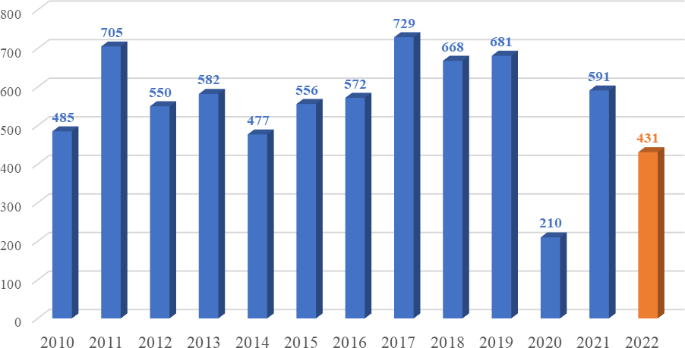

Gifts received by month

Among the gifts reported by public officials for 2022, the largest number was received in March, when 58 gifts were reported, then in October, in which month 55 gifts were received, and in August, when a total of 48 gifts were received. On the other hand, according to data from the reports, the lowest number of gifts was received in November - 19, while 22 were received in April and 26 in May.

Chart 1.2 - Number of gifts received by month
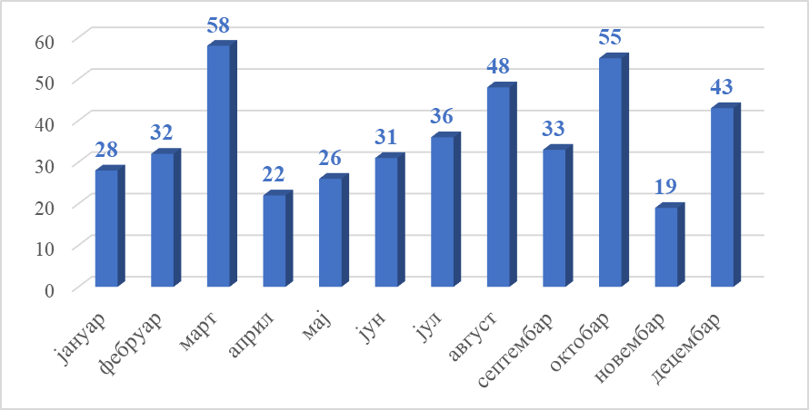

STATISTICAL OVERVIEW OF GIFTS RECEIVED ACCORDING TO TYPE OF GIFTS AND REGIME OF PROPERTY

Gifts received by type of gift

The Law defines that public officials can receive protocol gifts and occasional gifts in connection with the discharge of public office. The structure of gifts reported by public officials for 2022 is such that a total of 316 protocol gifts were received, i.e. 73.32%, while a total of 115 occasional gifts were received in the same year, i.e. 26.68% of the total number of gifts received.
The largest number of protocol gifts were received by the President of the Republic - 111 gifts, the Minister of Internal Affairs - 71 gifts and the Minister of Foreign Affairs - 41 gifts.

Chart 2.1 - Structure of received gifts by type

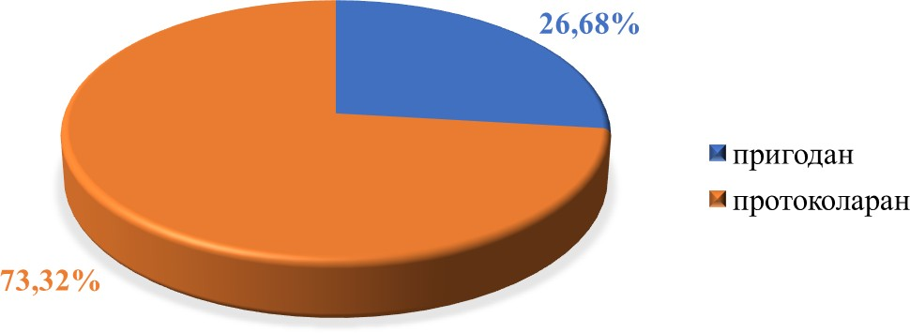

Of the total number of gifts received in 2022, 355 gifts, or 82.37%, were transferred to the regime of public property, while 76 gifts, or 17.63%, were retained in the regime of personal property of public officials.

Chart 2.2 - Structure of the property regime of received gifts

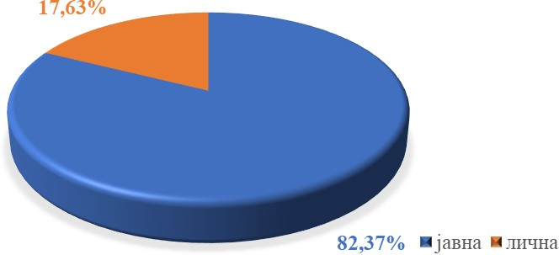

RELATION OF PUBLIC AUTHORITIES AND THE PROPERTY REGIME OF THE GIFTS

For the year 2022, 35 bodies of all levels of public authority submitted gift records to the Agency, which is an increase compared to the previous year, when 28 bodies submitted gift records.
According to data from the submitted records, the President of the Republic received the largest number of gifts - 111 gifts, followed by the Ministry of Internal Affairs - 71 gifts, the Ministry of Defense - 50 gifts and the Ministry of Foreign Affairs - 41 gifts.
Among the public authorities that submitted records of gifts to the Agency, in 21 of them, public officials transferred all gifts to the regime of public property, and in nine bodies, all the received gifts were kept as personal property of public officials. In the remaining five bodies, public officials transferred part of the gift to the public property regime, and kept a part as their personal property.

Table 3.1 - Number of received gifts by public authority and by property regime

Serial no. | Public authority | Property regime |  | Total
 |  | Public | Personal
1. | President of the Republic | 111 | 0 | 111
2. | General Secretariat of the President of the Republic | 1 | 0 | 1
3. | National Assembly¹ | 19 | 0 | 19
4. | Government² | 11 | 0 | 11
5. | Ministry of Interior | 71 | 0 | 71
6. | Ministry of Defense | 33 | 17 | 50
7. | Ministry of Foreign Affairs | 41 | 0 | 41
8. | Ministry of Agriculture, Forestry and Water Management | 0 | 9 | 9
9. | Ministry of Tourism and Youth | 1 | 5 | 6
10. | Ministry of Trade, Tourism and Telecommunications | 0 | 5 | 5
11. | Ministry of Finance | 2 | 0 | 2
12. | Ministry for European Integration | 0 | 1 | 1
13. | Security Information Agency | 4 | 0 | 4
14. | Military Intelligence Agency | 0 | 17 | 17
15. | Veterinary Directorate | 5 | 1 | 6
16. | Constitutional Court | 1 | 0 | 1
17. | State Auditing Institution | 1 | 0 | 1
18. | Assembly of AP Vojvodina | 1 | 0 | 1

¹ The gifts were received by the speakers of the National Assembly.
² The Prime Minister received the gifts.

Serial no. | Public authority | Property regime |  | Total
19. | Provincial Government of AP Vojvodina³ | 4 | 0 | 4
20. | Mayor of the City of Užice | 17 | 0 | 17
21. | Mayor of the City of Kragujevac | 7 | 2 | 9
22. | Mayor of Kraljevo | 8 | 0 | 8
23. | Mayor of the City of Smederevo | 1 | 5 | 6
24. | The mayor of the City of Kruševac | 5 | 0 | 5
25. | Mayor of the City of Sombor⁴ | 2 | 0 | 2
26. | Assembly of the City of Novi Sad | 2 | 0 | 2
27. | Mayor of the City of Novi Sad | 1 | 0 | 1
28. | President of Kanjiža Municipality⁵ | 0 | 7 | 7
29. | Municipal Council of Kanjiža municipality | 0 | 2 | 2
30. | Kanjiža Municipal Assembly | 0 | 2 | 2
31. | President of the Municipality of Bajina Bašta | 1 | 0 | 1
32. | President of the City Municipality of Pantelej - Nis | 4 | 0 | 4
33. | Postal Savings Bank | 1 | 0 | 1
34. | PUC Potiski vodovodi, Horgoš | 0 | 2 | 2
35. | PUC Naš dom, Apatin | 0 | 1 | 1
Total |  | 355 | 76 | 431

³ The gifts were received by the President of the Provincial Government.
⁴ The gifts were received by the Deputy Mayor of Sombor.
⁵ Gifts were received by the president of the municipality (five gifts), the deputy president of the municipality (one gift) and the assistant of the president of the municipality (one gift).

Chart 3.1 - Number of received gifts by public authority and property regime
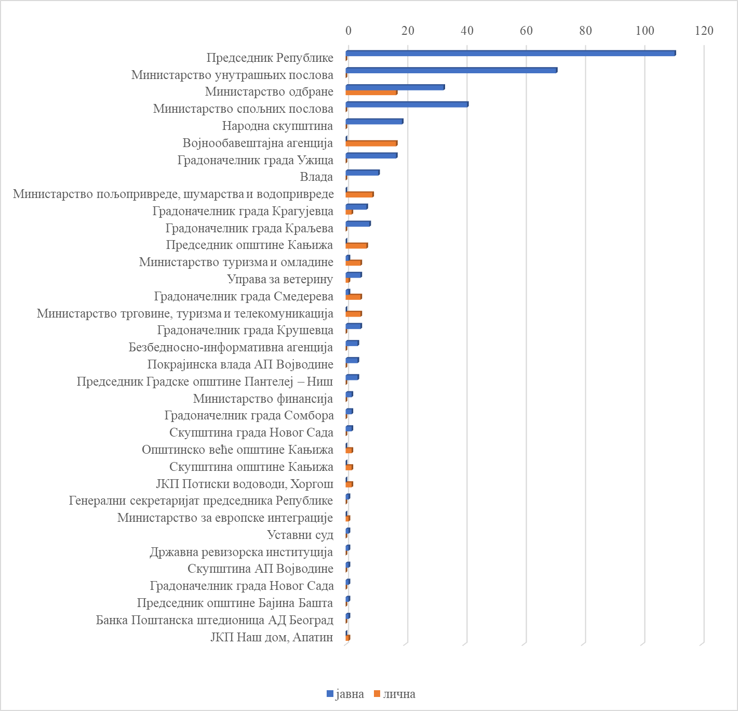

THE RELATION OF THE LEVEL OF PUBLIC AUTHORITY AND THE TYPE OF GIFT, REGARDING THE REGIME OF PROPERTY OF THE GIFT

The relation between the level of public authority and the type of gift

At the national level a total of 357 gifts have been received, of which 357 283 protocol and 74 occasional gifts.
At the provincial level, a total of five gifts were received, all of which protocol gifts.
At the local level, a total of 69 gifts were received, of which 28 were protocol gifts and 41 were occasional gifts.

Chart 4.1 - Relation between the level of public authority and the type of gift

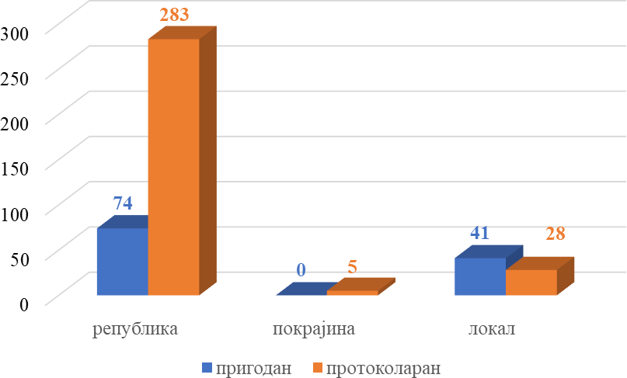

The relation between the level of public authority and the gift property regime

At the national level, out of a total of 357 gifts received, public officials kept 55 gifts as their personal property, while the remaining 302 gifts were transferred to the regime of public property.
At the provincial level, all five gifts received were transferred to public ownership.
At the local level, out of a total of 69 gifts received, public officials kept 21 gifts as their personal property, while 48 gifts were transferred to public ownership.

Chart 4.2 - The relation between the level of public authority and the gift property regime

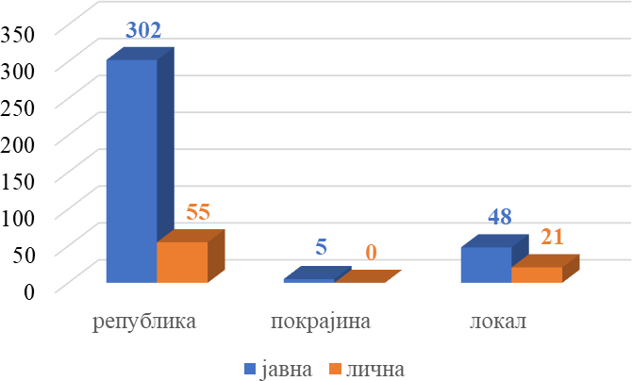

THE RELATION OF PUBLIC OFFICE AND THE GIFT PROPERTY REGIME

Regarding the relation between public offices and received gifts, the largest number of gifts were received by public officials at the national level, a total of 357. Government ministers received the most gifts - 167 and the President of the Republic - 111.
At the provincial level, a total of five gifts were received, of which four gifts were received by the President of the Provincial Government of AP Vojvodina, and one gift by the President of the Assembly of AP Vojvodina.
Public officials at the local level received a total of 69 gifts, of which 48 were received by mayors.
The majority of public officials, 23 of them, transferred all received gifts into public property. Five public officials kept certain gifts as their personal property, and transferred some to public ownership. Fourteen public officials kept all gifts as their personal possessions.
In terms of the number of gifts transferred to public ownership, the largest number were transferred by government ministers - a total of 147, while the President of the Republic is in second place with 111.
When it comes to gifts kept as personal property, the greatest number of gifts were kept by directors, a total of 21, followed by government ministers with 20 gifts.

Table 5.1 - Overview of the relation between public offices and the property regime of gifts

The relation between public offices and the property regime of gifts
Serial no. | Public office | Property regime |  | Total
 |  | Public | Personal
1. | President of the Republic | 111 | 0 | 111
2. | Advisor to the President of the Republic | 1 | 0 | 1
3. | Speaker of the National Assembly | 19 | 0 | 19
4. | Prime Minister | 11 | 0 | 11
5. | Minister | 147 | 20 | 167
6. | Assistant Minister | 0 | 11 | 11
7. | State Secretary | 1 | 6 | 7
8. | President of the Constitutional Court | 1 | 0 | 1
9. | President of the SAI Council | 1 | 0 | 1
10. | Director (state bodies and public enterprises) | 9 | 21 | 30
11. | Vice-President of the Provincial Government | 4 | 0 | 4
12. | Speaker of the Provincial Assembly | 1 | 0 | 1
13. | Mayor | 41 | 7 | 48
14. | President of the city assembly | 2 | 0 | 2
15. | President of the municipality | 1 | 5 | 6

The relation between public offices and the property regime of gifts
Serial no. | Public office | Property regime |  | Total
 |  | Public | Personal
16. | Deputy mayor of the municipality | 0 | 1 | 1
17. | Assistant to the mayor of the municipality | 0 | 1 | 1
18. | President of the municipal assembly | 0 | 2 | 2
19. | Member of the municipal council | 0 | 2 | 2
20. | President of the city municipality | 4 | 0 | 4
21. | President of the company assembly | 1 | 0 | 1
Total |  | 355 | 76 | 431

Chart 5.1 - Presentation of the relation between public offices and the regime of gift property
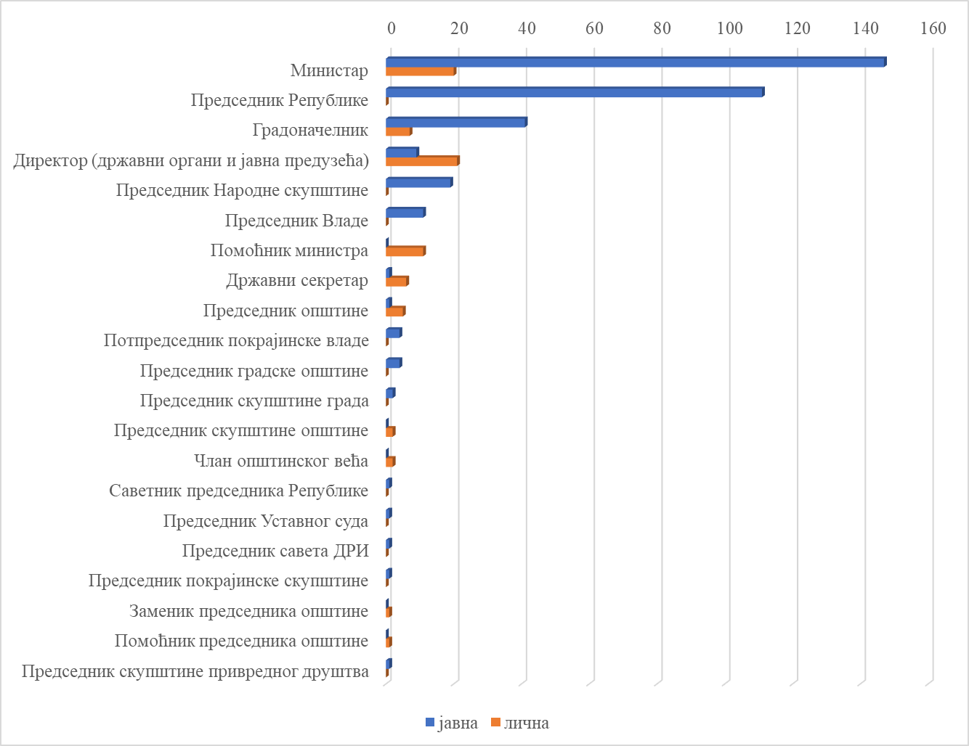

THE RELATION OF PROPERTY AND THE ESTIMATED VALUE OF THE GIFT

The estimated value of gifts received by public officials ranges from 200.00 to 250,000.00 dinars. For 45 gifts, the estimated monetary value has not yet been determined, that is, the evaluation is ongoing. The estimated monetary value of the largest number of gifts is in the range from 3,000.00 to 10,000.00 dinars, a total of 146, of which public officials kept 23 as their personal property, while 123 gifts were transferred to public property. A smaller number of gifts are worth up to 3,000.00 dinars, 109 of them, of which 56 were transferred to public property, and 53 were kept as personal property.
All gifts with an estimated value over RSD 10,000.00 (131) were transferred to public property. The estimated value of five gifts is 250,000.00 dinars each, and they are three vases, a figure of a large eagle on a branch in the color of gold and a pistol with 16 bullets.

Chart 6.1 - The relation between the property regime and the estimated value of the gift

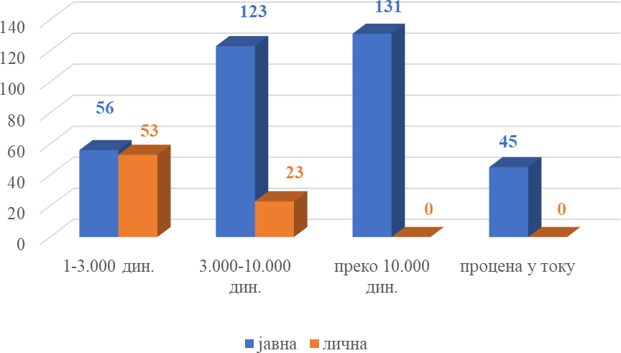

OVERVIEW OF PUBLIC OFFICIALS WHO RECEIVED GIFTS

For 2022, a total of 42 public officials at all levels of government reported receiving gifts.

Table 7.1 - List of public officials who received gifts in 2022

Serial no. | Surname and first name of the official | Number of gifts
1. | Ljiljana Asković | 1
2. | Agneš Baganj | 1
3. | Predrag Bandić | 11
4. | Ana Brnabić | 11
5. | Jovan Beč | 6
6. | Zoltan Vaš | 1
7. | Aleksandar Vulin⁶ | 60
8. | Miloš Vučević⁷ | 10
9. | Aleksandar Vučić | 111
10. | Bratislav Gašić⁸ | 15
11. | Dušan Glišić | 2
12. | Ivica Dačić⁹ | 14
13. | Nikola Dašić | 9
14. | Branka Đukić | 1
15. | Vesna Đurić | 1
16. | Aleksandar Zivković | 5
17. | Robert Konja | 1
18. | Robert Lacko | 2
19. | Siniša Mali | 2
20. | Snežana Marković | 1
21. | Tatjana Matić | 5
22. | Husein Memić | 6
23. | Emina Milakara | 6
24. | Igor Mirović | 4
25. | Tanja Miščević | 1

⁶ The public official received 59 gifts as Minister of the Interior, and one gift as Director of BIA. ⁷ The public official received one gift in the office of mayor, and nine gifts as Minister of Defense. ⁸ The public official received three gifts as the director of BIA and 12 gifts as the Minister of Interior.
⁹ The public official received eight gifts in the office of Speaker of the National Assembly, and six gifts in the office of Minister of Foreign Affairs.

Serial no. | Surname and first name of the official | Number of gifts
26. | Vladimir Orlić | 11
27. | Jasmina Palurović | 5
28. | Ištvan Pastor | 1
29. | Dusko Pejović | 1
30. | Jelena Radivojević Raković | 17
31. | Jelena Radomirović Marinković | 2
32. | ​Nebojša Rakić | 1
33. | Nikola Selaković | 35
34. | Nebojša Smiljanić | 1
35. | Stanković Nataša | 4
36. | Nemanja Starović | 2
37. | Nebojša Stefanović | 23
38. | Zoran Stojković | 17
39. | Jelena Tanasković | 9
40. | Predrag Terzić | 8
41. | Ljiljana Tica | 2
42. | Robert Feistamer | 5
TOTAL |  | 431

GENDER DIMENSION OF PUBLIC OFFICIALS WHO RECEIVED GIFTS

Gift recipients by gender

In 2022, a total of 42 public officials received a gift in discharging public office, of which 27 men, i.e. 64.29% and 15 women, i.e. 35.71%.

Chart 8.1 - Structure of gift recipients by gender

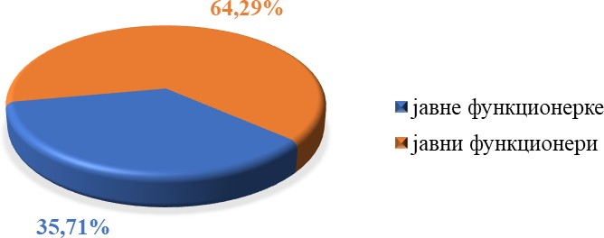

The number of gifts received, classified by the gender of the recipient

Out of a total of 431 reported gifts in the observed year, public officials received 364 gifts, i.e. 84.45%, while female public officials received 67 gifts, i.e. 15.55%.

Chart 8.2 - Structure of the number of gifts received according to the gender of the recipient

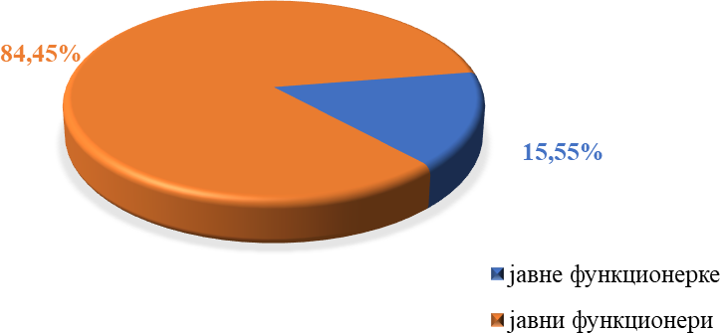

Ratio of gift recipients by gender and ranges of estimated values

The largest number of gifts received by public officials is in the range of estimated value from 3,000.00 dinars to 10,000.00 dinars, namely 146, i.e. 37.82% in relation to the total number of gifts received in 2022. The largest number of gifts received by female public officials is in the range of estimated value from 1.00 to 3,000.00 dinars, namely 22, or 44.90%.
Only one female public official received a gift with an estimated value of more than RSD 40,000.00.
A total of 45 received gifts, the value assessment of which is in progress, were not included in the statistical processing and graphic display according to the set criteria.

Chart 8.3 –
Structure of gift recipients by gender and ranges of estimated values

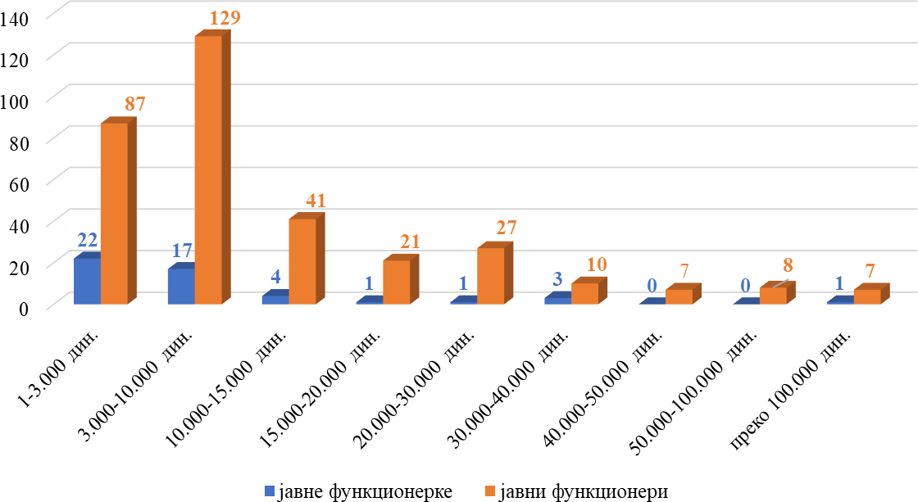

Total and average estimated values ​​of received gifts, classified by gender of recipient

The total estimated value of gifts received in 2022 is 5,999,525.78 dinars. The estimated value of gifts received by public officials is 5,424,817.61 dinars (90.42%), while the estimated value of gifts received by female public officials is 574,708.95 dinars (9.58%).
The average estimated value of gifts received by public officials is 16,097.38 dinars, while the average value of gifts received by female public officials amounts to 11,728.44 dinars. From the above values, it follows that the estimated value of gifts received by public officials is 37% higher than the average value of gifts received by female public officials.
A total of 45 received gifts, whose value assessment is in progress, were not included in the statistical processing and graphic display according to the set criteria.

Graph - 8.4 Estimated value of received gifts by gender of recipient

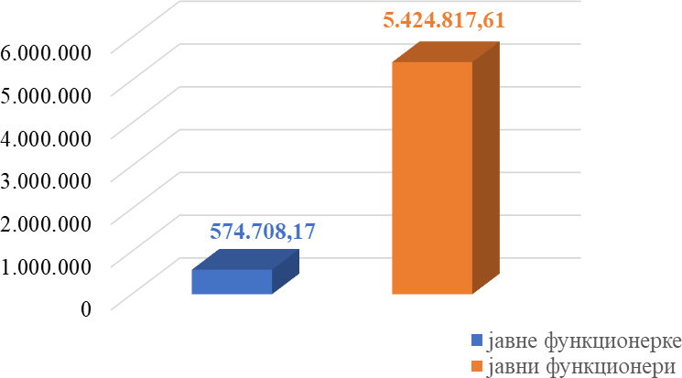

Chart – 8.5 Average estimated values ​​of received gifts by gender of recipient

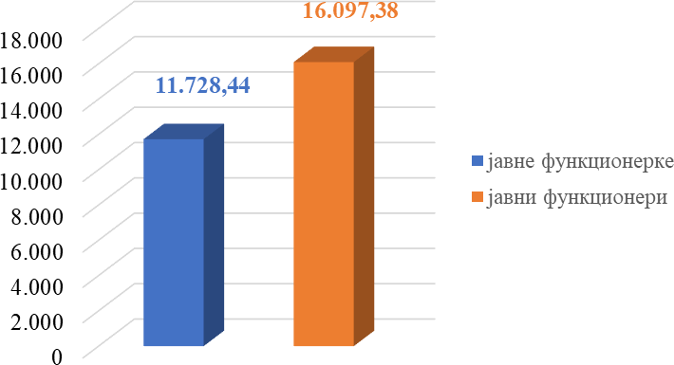

OVERVIEW OF GIFTS RECEIVED

Table 9.1 - Overview of received gifts

Serial no. | Type of gift | Number  of gifts
1. | Dagger | 1
2. | Vase | 12
3. | Gusle | 1
4. | Binoculars | 2
5. | Board game | 1
6. | Thank-you note | 5
7. | Calendar | 7
8. | Book | 46
9. | Cosmetic products | 1
10. | Coin | 13
11. | Set of books | 2
12. | Tie | 2
13. | Mockup | 13
14. | Jewelry | 5
15. | Clothing items | 3
16. | Medal | 1
17. | Trophy | 2
18. | Bottle of drink | 34
19. | Pistol with 16 bullets | 1
20. | Plaque | 41
21. | Flask | 1
22. | Folk handicrafts items | 10
23. | Food products | 13
24. | Writing utensils | 8
25. | Agenda | 12
26. | Saber | 1
27. | Watch | 6
28. | Axe | 2
29. | Dish set | 8
30. | Set of postage stamps | 6

Serial no. | Type of gift | Number of gifts
31. | Painting | 58
32. | Sports souvenir | 11
33. | Souvenir | 73
34. | Tablet | 1
35. | Plate | 30
36. | Carpet | 4
37. | Bag | 1
38. | Decoration | 6
39. | Figure | 25
40. | Photograph | 4
41. | Flowers | 5
42. | Chess set | 3
43. | Cup | 8
TOTAL |  | 489

* Note: The total number of gifts shown in this table is greater than the number of gifts reported in the catalog of gifts, because some public officials received several individual gifts as part of one gift, especially in the case of books, photographs, etc.

